Exercises

**Q1. Consider a database LOANS with the following tuples:**

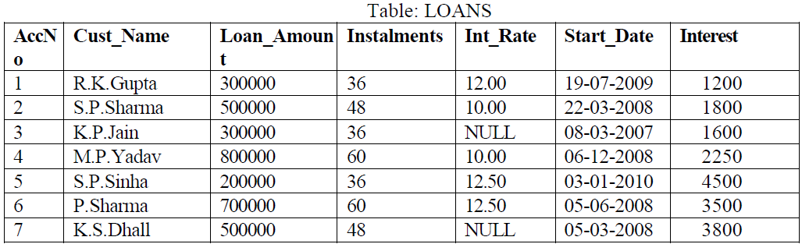

1. Create the table Loans and insert tuples in it.

create table Loans(AccNo int,Cust_Name varchar(30),Loan_Amount int,Instalments int,Int_Rate num

ber(5,2),Start_Date date,Interest number);

create table loans(AccN integer,Cust_Name varchar(25),Loan_Amount integer,Instalments number,Int_Rate number(5,2),Start_Date date,Interest number);

desc loans;

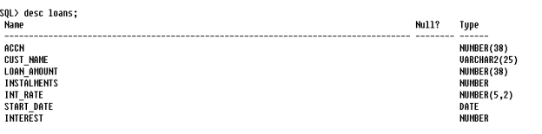

insert into loans values(1,'R.K. Gupta',300000,36,12.00,'19-JUL-09',1200);

1. Display the details of all the loans.

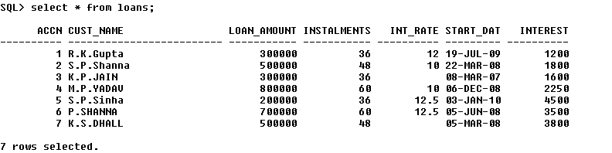

1. Display the AccNo, Cust_Name, and Loan_Amount of all the loans.

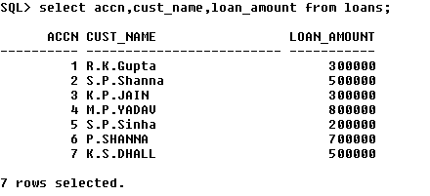

Conditional Select using Where Clause

1. Display the details of all the loans with less than 40 instalments.

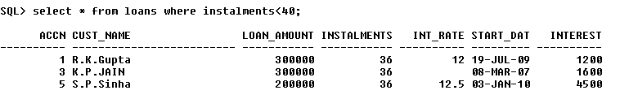

1. Display the AccNo and Loan_Amount of all the loans started before 01-04-2009.

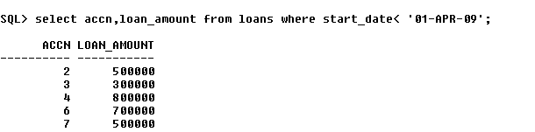

1. Display the Int_Rate of all the loans started after 01-04-2009.

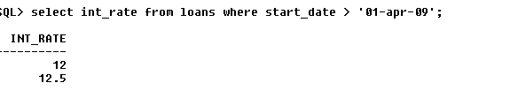

Using NULL

1. Display the details of all the loans whose rate of interest is NULL.

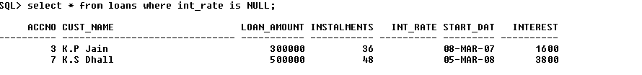

1. Display the details of all the loans whose rate of interest is not NULL.

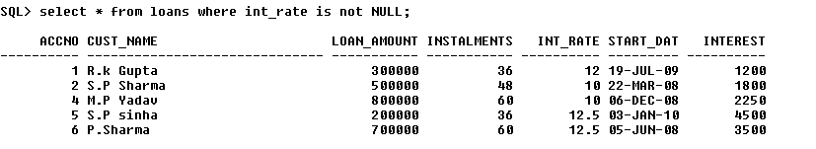

Using DISTINCT Clause

1. Display the amounts of various loans from the table LOANS. A loan amount should appear only once.

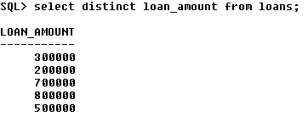

1. Display the number of installments of various loans from the table LOANS. An instalment should appear only once.

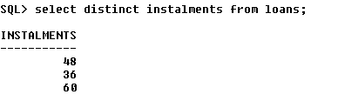

Using Logical Operators (NOT, AND, OR) and Between

1. Display the details of all the loans started after 31-12-2008 for which the number of instalments are more than 36.

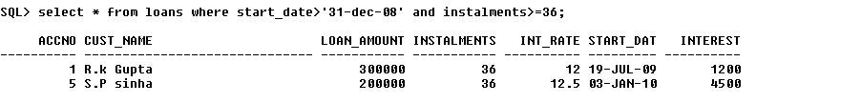

1. Display the Cust_Name and Loan_Amount for all the loans which do not have number of instalments 36.

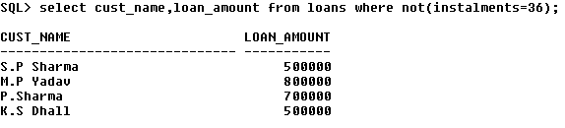

1. Display the Cust_Name and Loan_Amount for all the loans for which the loan amount is less than 500000 or int_rate is more than 12.

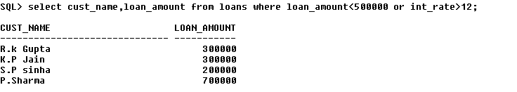

1. Display the details of all the loans whose Loan_Amount is in the range 400000 to 500000.

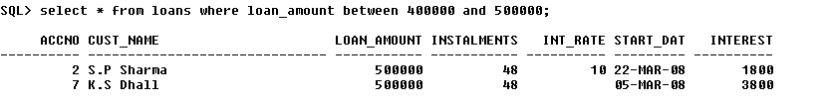

1. Display the details of all the loans whose rate of interest is in the range 11% to 12%.

Using IN Operator

1. Display the Cust_Name and Loan_Amount for all the loans for which the number of installments are 24, 36, or 48. (Using IN operator)

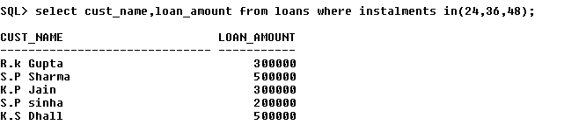

Using LIKE Operator

1. Display the AccNo, Cust_Name, and Loan_Amount for all the loans for which the Cust_Name ends with 'Sharma'.

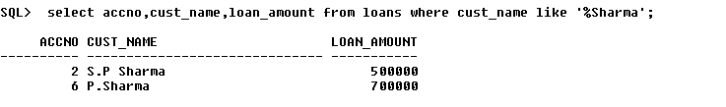

1. Display the AccNo, Cust_Name, and Loan_Amount for all the loans for which the Cust_Name ends with 'a'.

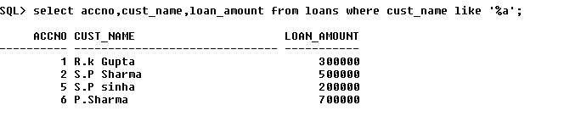

1. Display the AccNo, Cust_Name, and Loan_Amount for all the loans for which the Cust_Name contains 'a'.

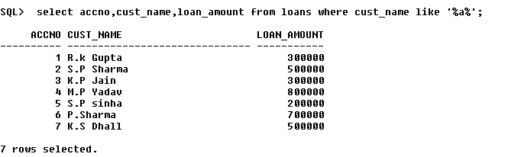

1. Display the AccNo, Cust_Name, and Loan_Amount for all the loans for which the Cust_Name does not contain 'P'.

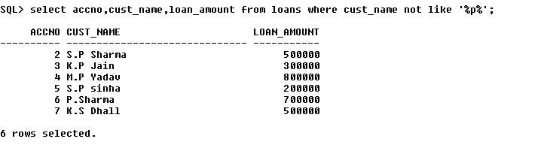

1. Display the AccNo, Cust_Name, and Loan_Amount for all the loans for which the Cust_Name contains 'a' as the second last character.

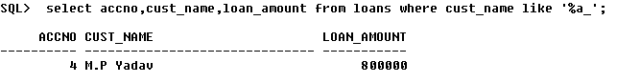

Using ORDER BY clause

1. Display the details of all the loans in the ascending order of their Loan_Amount.

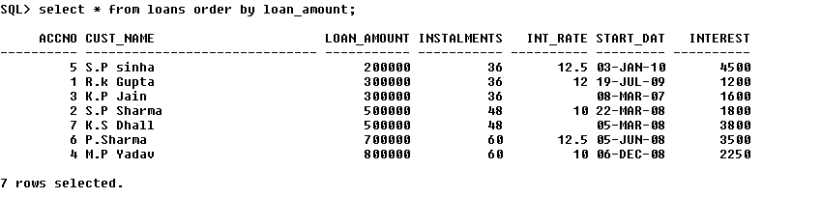

1. Display the details of all the loans in the descending order of their Start_Date.

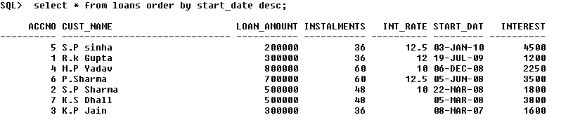

Using UPDATE, DELETE, ALTER TABLE

1. Put the interest rate 11.50% for all the loans for which interest rate is NULL.

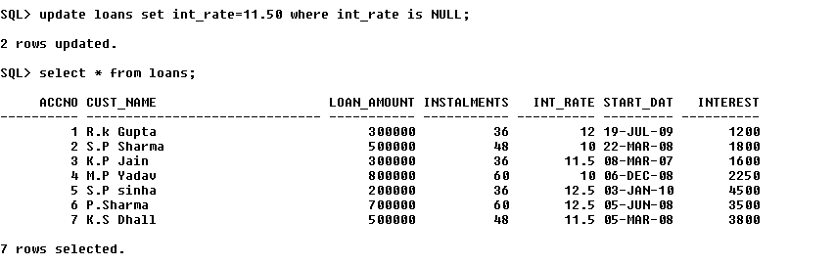

1. Increase the interest rate by 0.5% for all the loans for which the loan amount is more than 400000.

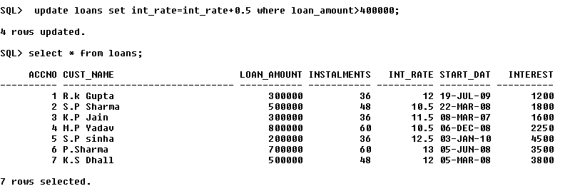

1. For each loan replace Interest with (Loan_Amount*Int_Rate*Instalments) 12*100.

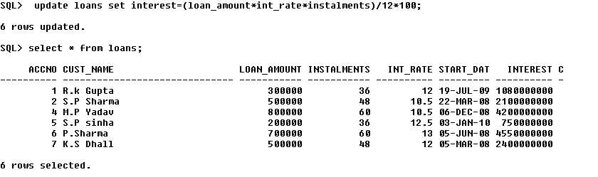

1. Delete the records of all the loans of 'K.P. Jain'

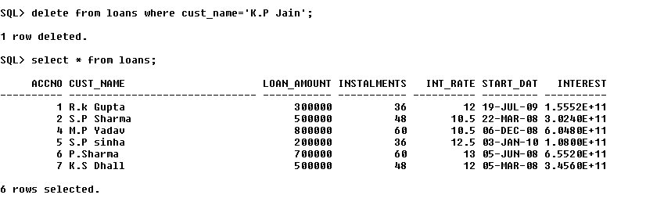

1. Add another column Category of type CHAR(1) in the Loan table.

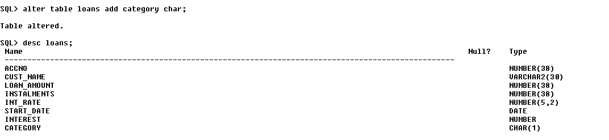

Using Aggregate Functions

1. Display the sum of all Loan Amount for whose Interest rate is greater than 10.

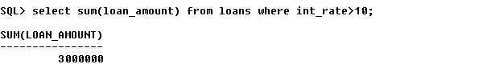

1. Display the Maximum Interest from Loans table.

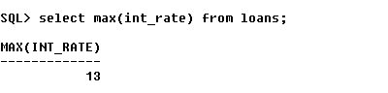

1. Display the count of all loan holders whose name is ending with ‘Sharma’.

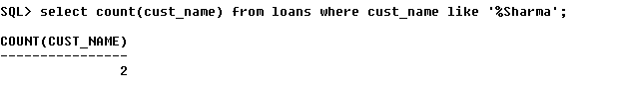

1. Display the count of all loan holders whose Interest is Null.

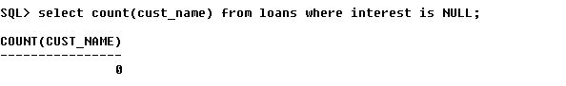

Using Group By Clause

1. Display the Interest wise details of Loan Account Holders.

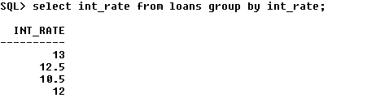

1. Display the Interest wise details of Loan Account Holders with at least 10 installments remaining.

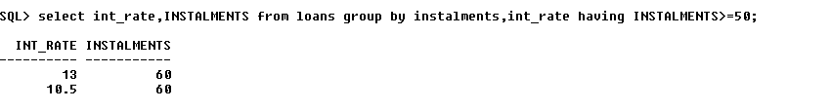

1. Display the Interest wise count of all loan holders whose Installment due is more than 5 in each group.

